**CAREER EPISODE 3**

**3.1INTRODUCTION**

|  |  |
| --- | --- |
| Title | **Using Recycled Plastic to Make Paver Blocks** |
| Location | Wanjiali South RD, Changsha |
| University | Changsha University of science and technology |
| Department | Civil Engineering |
| Supervisor | Hong Li |
| Subject | Traffic engineering B |
| Date | September 2015 – November 2015 |

**3.2 BACKGROUND**

**3.2.1 NATURE OF THE PROJECT**

The project, titled “Using Recycled Plastic to Make Paver Blocks” is related to the usage of recycled plastic in the paver blocks because that is a creative solution to the environmental problems caused by plastic waste. Paver blocks which are made from recycled plastics are more environmentally friendly and sustainable. The production of paver blocks from recycled plastic plays an important role in reducing plastic waste in the surroundings and decreasing the use of non-renewable resources. This technology has the potential to transform the road construction industry by offering a sustainable, cost-effective, and efficient solution for building roads and pavements.

Various tasks were performed for determining the feasibility of using recycled plastic in paver production. During this project work, recycled plastic was sourced and its properties were tested, including its strength and durability. Mix designs were formulated, and then testing of various combinations of materials and proportions was carried out to determine the optimal mix. Paver blocks were then casted using moulds, and the blocks were cured and tested for compressive strength and water absorption. The environmental impact of using recycled plastic in paver block production was also thoroughly studied by conducting life cycle assessments.

**3.2.2 OBJECTIVES**

The key objective of this project is to reduce plastic waste by utilizing recycled plastic to make paver blocks. Likewise, other minor objectives were as follows.

* To provide an eco-friendly alternative to traditional paver blocks made from non-biodegradable materials.
* To obtain the necessary tests and experimental design along with the suitable mix ratio based on the block type.

**3.2.3 PARTICULAR WORK NATURE**

I studied in detail the sustainable way of using plastic waste in paver blocks. I reviewed the benefits of incorporating waste plastic in asphalt mixtures, including improved durability, increased resistance to deformation and cracking, and reduced maintenance costs. Additionally, I studied the recent scenario of plastic waste and how much was produced yearly. Also, I gained an in-depth understanding of the magnitude of the plastic waste problem and its impact on the environment. I applied my knowledge of coarse aggregate, fine aggregate, plastic, and cement to implement a successful project. I used my understanding of the properties and behavior of each component to design an optimal mix ratio that incorporated recycled plastic into the concrete mix for the production of paver blocks. I utilized two approaches in the fabrication of paver blocks that was the heating method and the compression method.

**3.2.4 ORGANIZATION CHART**

**Figure 1: Organizational Chart**

**3.2.5 DUTIES AND RESPONSIBILITIES**

* To review various literary papers and articles papers to understand the tasks necessary for achieving the project objectives.
* To identify suitable materials for utilizing waste plastic in bituminous mixes for road construction by conducting research.
* To classify and categorize the materials based on their properties and effectiveness in improving the performance of the bituminous mixes.
* To optimize the mix design by developing and testing different formulations of bituminous mixes with varying amounts and types of waste plastic.
* To evaluate the strength, durability, and other properties of the resulting bituminous mixes for ensuring that they meet relevant road construction requirements.

**3.3 PERSONAL ENGINEERING ACTIVITY**

**3.3.1**

At first, I reviewed various journals and articles on the topic of eco-friendly paver blocks that were made from plastic waste. Additionally, I studied in detail the sustainable way of using plastic waste in paver blocks. Furthermore, I examined the characteristics of waste plastic and its benefits in road construction. Also, I reviewed the concept of the implementation of waste plastic in bituminous mixes for use in road construction. I gained detailed knowledge of the proportions of plastic waste, cement, and aggregates that were needed for use in road construction. I also gathered a thorough knowledge of waste plastic classifications and also got to know about how plastic waste was useful for road construction as well. In addition to that, I studied the properties specifically of each class needed to fulfill the basic requirements for fulfilling requirements for sustainable road construction. Following that, I also collected details related to the laboratory tests and site tests necessary for the required quality and quantity of plastic waste for constructing long-lasting roads.

**3.3.2**

After that, I gained in-depth information related to plastic waste generation and methods for classifying them. I also reviewed how much plastic waste was utilized yearly based on the data. Then, I learned about the criteria for blending plastic waste with coarse aggregate, fine aggregate, and sand for getting optimal mixing. During my consideration, I considered that the aggregate made up 60 to 75 percent of the total volume of concrete and was classified into two separate categories fine and coarse. Furthermore, I examined the properties of the aggregate that affected the durability, workability, and strength of the concrete. I included the categories of plastic waste, including hard plastic waste such as laminated plastic, low-density polyethylene, polyvinyl chloride, and acrylonitrile butadiene styrene. I included information on how cement was mixed with other materials in a specific ratio to achieve the desired binding strength. Then, I proceeded to analyze the adhesive properties of the resulting cement.

**3.3.3**

After that, I employed a manual shredding technique using scissors to break down a mineral water bottle composed of polyethylene terephthalate polymer. Also, I observed how that approach made the melting process of the material much easier. Afterward, considering the fabrication method, I utilized the shredded bottles as a binder and sand replacement in the production of the paver blocks. In the heating process, I utilized recycled plastic as a binder. After that, the plastic was heated in an oven before being mixed with quarry dust and sand. In addition to that, for the compression method, I processed the recycled plastic and turned it into fine particles by passing it through a 0.6mm sieve. Then, I utilized both methods of recycled plastic as a component, with the heating method I relied on melted plastic as a binder, and with the compression method I utilized finely sieved plastic particles. Following that, I prepared trial mixes to observe the most suitable method for producing paver blocks and to determine the appropriate mix design.

**3.3.4**

Likewise, I utilized two approaches in the fabrication of paver blocks that was the heating method and the compression method. In addition to that, for the heating method, I mixed ragged PET bottles along with quarry dust in a mould and heated the mixture organized in an oven at a constant heat of 240-290ºC. After heating, I then stirred the mixture thoroughly by hand to ensure it was well-mixed. Subsequently, I poured it into a mould and then left it to cool and harden for one day. Furthermore, for the compression method, I used a mixture of sand, cement, and recycled plastic. After that, I shredded the PET bottles, melted the plastic, and allowed it to harden before crushing it into finer particles. For this method, I used plastic powder as a replacement for sand. Similarly, I utilized the compression method in which plastic powder acted as a replacement for sand. I also poured the mixture into a mould as shown in **Figure 2** and then, I crushed it by using a compressive strength machine.

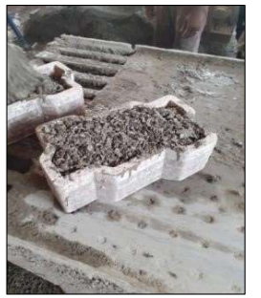

**Figure 2: Quarry dust in a mould**

**3.3.5**

Then, during the trial mixing stage, I selected and used the most efficient procedure. For the mix ratio, I considered 15% of cement for block types A, B, and C, but I factored in a plastic waste percentage of 0% for block type C, 15% for block type B, and 30% for block type A. Following that, for the aggregate, I included 70% with 40% coarse aggregate and 30% fine aggregate for block type A. In block type B, I considered 80% with 45% coarse aggregate and 35% fine aggregate. For block type C, I used 90% with 50% coarse aggregate and 40% fine aggregate. Then, I conducted a compressive strength test by placing the sample in a Universal testing machine as shown in **Figure 3**, and a water absorption test that involved measuring the weight gain of a single surface-exposed specimen over time to determine the rate of water absorption. I tabulated the obtained data for both tests in **Table 1** and developed a graph using those data as shown in **Figure 4 and Figure 5**. Then, I calculated the amount of water absorbed by using the formula (Dry Weight – Wet Weight) ×100. From the results of the tests, I found that the concrete mix paver possesses lower strength than the plastic paver block.

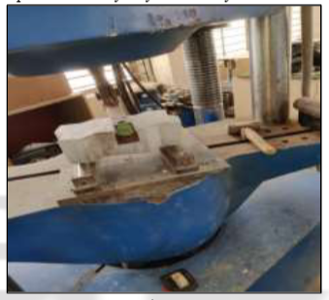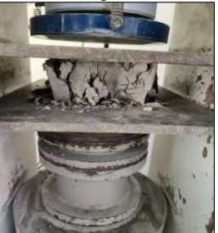

**Figure 3: Sample placing and testing in Universal testing machine**

**Table 1: Results**

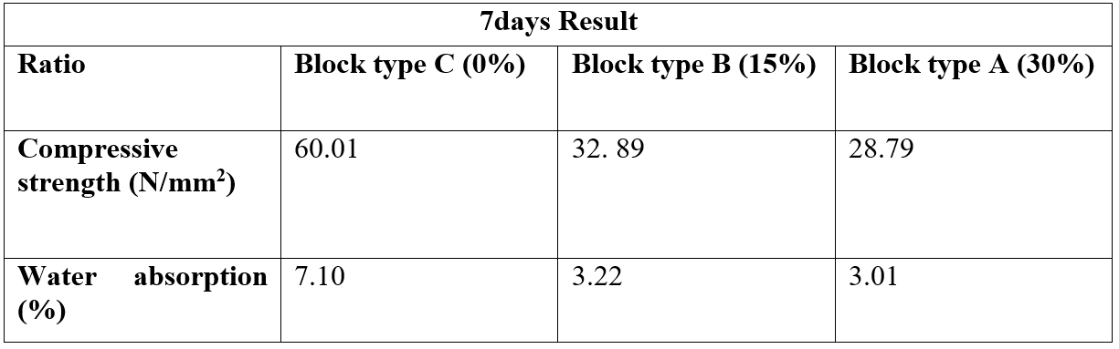

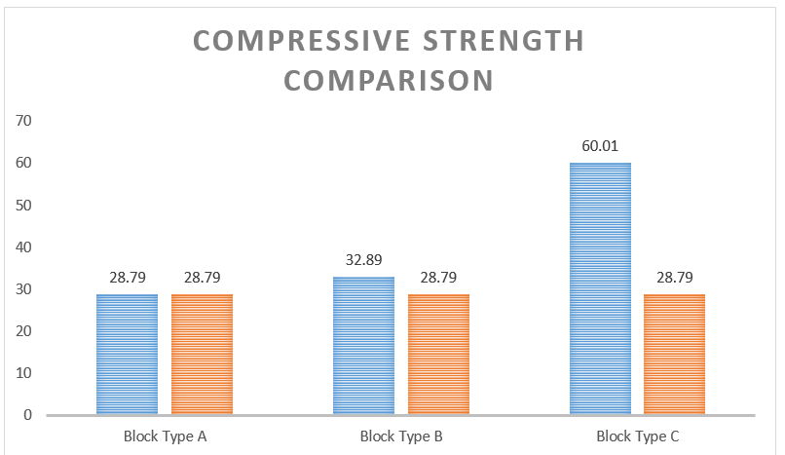

**Figure 4: Compressive Strength Comparison**

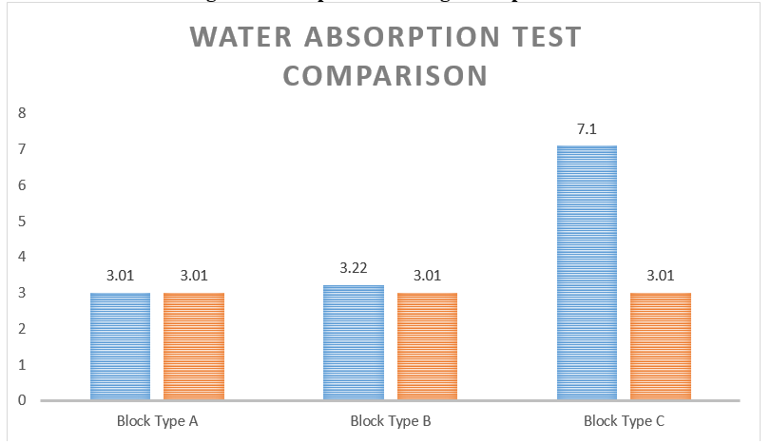

**Figure 5: Water Absorption Comparison**

**3.4 PROBLEMS AND SOLUTIONS**

**3.4.1**

While performing the project work, I observed that pure plastic roads are susceptible to melting, which can result in structural weakness and premature failure. To address this issue, I conducted extensive research on how to improve the durability of plastic roads. Through my research, I discovered that compatible plastic such as HDPE and PP can be used to increase the melting point of the plastic and make it more resistant to deformation caused by heat.

**3.4.2**

Another problem I identified was during the compressive and water absorption tests with the paver blocks, which exhibited low strength and high-water absorption rates. Then, I discussed the issue within a group and collaborated with my team members to identify the root cause and develop a new mix design. We used stronger and more durable materials and adjusted the curing process to improve the quality of the paver blocks. Through my collaborative work approach and effort, I found a solution to the problem.

**3.5 CREATIVE WORKS**

I inspected the idea of utilizing waste plastic production in bituminous mixes for sustainable and high-durability road construction. I discovered an effective technique and conducted tests to reduce plastic waste, thereby contributing to a cleaner environment. I classified plastic waste into six distinct categories, which included Polythene, Polypropylene, Laminated Plastic, Low-Density Polyethene, Polyvinyl Chloride, and Acrylonitrile Butadiene Styrene. I applied the proper mix ratio of plastic waste to the cement to the aggregate.

**3.6 STANDARD CODES AND ETHICS**

I followed the IS 516:1959 code while carrying out the strength test in this project. I maintained engineering discipline while performing this project.

**3.7 TEAMWORK COORDINATION**

My team and I delved into a comprehensive study on the benefits of utilizing plastic waste in road construction. After that, I stayed in close contact with our project supervisor to ensure that the project was carried out smoothly because I was in charge of the project and was also responsible for giving each team member a specific task for our project. I also set up frequent team meetings for discussing each task in detail and giving individual tasks to every team member as well. I then organized each team member’s report section according to the assignment they were given and combined the section to produce a thorough final report. After that, I submitted the final report on plastic waste in road construction to the faculty of review.

**3.8 SUMMARY**

The appropriate methods for plastic waste road construction technology were thoroughly researched in this project. I also considered the yearly consumption of plastic in India as part of additional research. Following that, I categorized the plastic waste into six categories and carefully applied an appropriate technique to execute the mixing process. Furthermore, experimental designs were developed to overview the optimal techniques for both paver block production and mix design. Then, the mix ratio block type was subsequently divided into four additional categories. Also, after conducting the compressive strength test, a water absorption test was also performed.

Through the execution of compressive strength and water absorption tests, I enhanced my competence in handling specimens. By conducting a thorough analysis of project-related tests, I discovered an effective and suitable technique for the mix ratio of plastic waste to the cement to the aggregate.